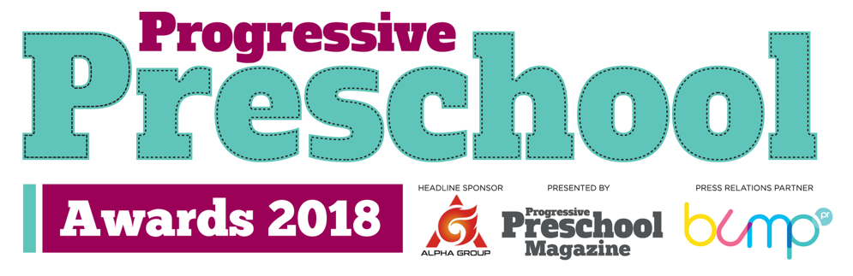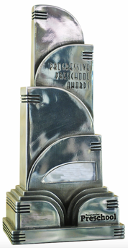

Retailer Nomination

Retailers may nominate themselves, or be nominate by suppliers or other contacts. Either way, please complete this form and email to robw@max-publishing.co.uk by Friday August 3, 2018.

The retail categories are:

- Best Supermarket Retailer of Preschool Products
- Best Multiple Retailer of Preschool Products
- Best Mixed Retailer Retailer of Preschool Products
- Best Department Store Retailer of Preschool Products
- Best Online Retailer of Preschool Products
- Best Preschool Retail Initiative
- Best Independent Nursery Retailer
- Best Independent Apparel Retailer
- Best Independent Toy Retailer
- Best Independent Gift Retailer

Nominated by (company):

Nominate by (name):

Telephone:

Email:

Date of Entry:

Keep up to date with the PPS Awards on PreschoolNews.net
@Prog_Preschool #PPSA18
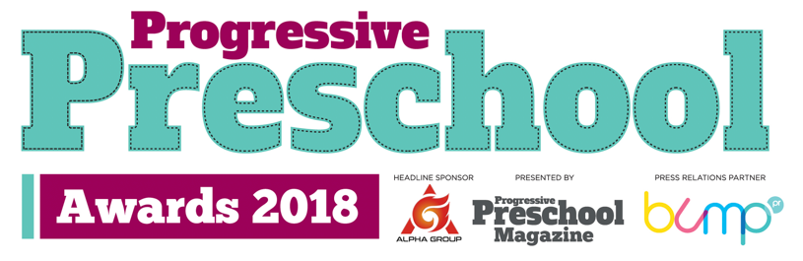

Retailer name:

Retailer town/city:

Contact at retailer:

Awards retail category entered:

Reason for nomination:

Retailer name:

Retailer town/city:

Contact at retailer:

Awards retail category entered:

Reason for nomination:

Retailer name:

Retailer town/city:

Contact at retailer:

Awards retail category entered:

Reason for nomination:

Retailer name:

Retailer town/city:

Contact at retailer:

Awards retail category entered:

Reason for nomination:

Retailer name:

Retailer town/city:

Contact at retailer:

Awards retail category entered:

Reason for nomination:

